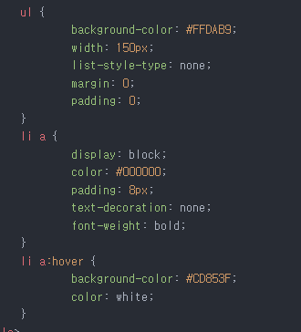

ul {

background-color: #FFDAB9; width: 150px; list-style-type: none; margin: 0; padding: 0;

Ti a {

display: block; color: #000000; padding: 8px; text-decoration: none; font-weight: bold;

Ti a:hover {

background-color: #CD853F; color: white;